SIMATS ENGINEERING (SAVEETHA SCHOOL OF ENGINEERING)
Department of Artificial Intelligence and Data Science
ASSESSMENT TOOL 3 – CODING CHALLENGE

Course Code: | DSA03 | Course Title: | Natural Language Processing
CO Assessed: | CO1 – Imitation (L1) | Assessment: | Assessment Tool 3 – Coding Challenge
Weightage: | 30% of CIA
CO5 Statement: | Analyse NLP models, regular expression patterns, finite state automata, morphological processing techniques and to interpret language processing. (BL-3)
Student Name: | C.Ishwarya | Reg. No.: | 192472108
Section / Batch: | CSE AI | Date: | 16/07.2026

Code of Conduct
I C.Ishwarya(192472108) (Name / Reg No) certify that this submission is my original work and that I have adhered to the guidelines specified for this assessment. I understand that any violation of academic integrity rules will result in disciplinary action.
Signature of the Student: __Ishwarya_______________________

Instructions
- Develop a complete and modular Python program that meets all the functional requirements specified in the coding challenge using appropriate algorithms, data structures, and programming practices.
- Test the program using multiple valid and invalid test cases, and clearly display the input, processing, and output to verify the correctness of the implementation.
- Follow standard coding practices by using meaningful variable names, proper indentation, comments, exception handling (where applicable), and upload the source code, sample outputs, and README file to the designated GitHub repository.
- Duration: 40 minutes.

Section / Topic | Focus | Q Nos
Regular Expression Pattern Matching | Regular Expressions, Basic Regular Expression Patterns | 1
Finite State Automata Implementation | Finite State Automata, Models and Algorithms | 2
Advanced Regular Expression Search | Regular Expressions, Basic Regular Expression Patterns | 3

1] Intelligent Email and Password Validator using Regular Expressions

PROBLEM UNDERSTANDING:
Develop a Python program to validate an Email Address, Password, and Mobile Number using Regular Expressions based on the specified validation rules.

ALGORITHM:
1) Import the re module.
2) Read email, password, and mobile number.
3) Validate each using regular expressions.
4) Display valid or invalid messages.

CODE:
import re
email=input("Enter Email: ")
password=input("Enter Password: ")
mobile=input("Enter Mobile Number: ")
if re.fullmatch(r'^[A-Za-z][A-Za-z0-9._]*@[A-Za-z]+\.(com|org|edu|net|in)$',email):
print("Valid Email")
else:
print("Invalid Email")
if re.fullmatch(r'^(?=.*[A-Z])(?=.*[a-z])(?=.*\d)(?=.*[@#$%&!]).{8,}$',password):
print("Strong Password")
else:
print("Weak Password")
if re.fullmatch(r'^[6-9]\d{9}$',mobile):
print("Valid Mobile Number")
else:
print("Invalid Mobile Number")

OUTPUT:
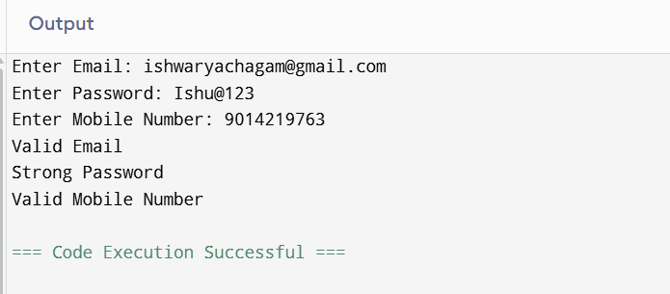

COMPETITIVE PERFORMANCE:
The program validates user inputs quickly using Python Regular Expressions and executes efficiently.

TEST CASE HANDLING:
- Valid Email
- Invalid Email
- Strong Password
- Weak Password
- Valid Mobile
- Invalid Mobile

RESULT:
The program successfully validates Email, Password, and Mobile Number.

2] Design a DFA Simulator
PROBLEM UNDERSTANDING:
Develop a Python program to simulate a DFA that accepts strings ending with "ab".

ALGORITHM:
1) Read the input string.
2) Start from state q0.
3) Change states according to the input characters.
4) If the final state is q2, accept the string.
5) Otherwise reject it.

CODE:
state="q0"
string=input("Enter String: ")
for ch in string:
if state=="q0":
if ch=='a':
state="q1"
elif state=="q1":
if ch=='a':
state="q1"
elif ch=='b':
state="q2"
elif state=="q2":
if ch=='a':
state="q1"
else:
state="q0"
if state=="q2":
print("Accepted")
else:
print("Rejected")

OUTPUT:
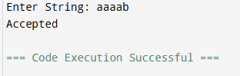

COMPETITIVE PERFORMANCE :
The DFA processes one character at a time, making it efficient with linear time complexity.

TEST CASE HANDLING :
Input | Output
ab | Accepted
aaab | Accepted
aba | Rejected
baba | Rejected

RESULT:
The DFA simulator correctly accepts strings ending with "ab" and rejects others.

3] Smart Pattern Matching Engine
PROBLEM UNDERSTANDING:
Develop a Python program to search Dates, Phone Numbers, Hashtags, Mentions, Prefixes, and Suffixes using Regular Expressions.

ALGORITHM:
1) Import the re module
2) Read the input text.
3) Display the search menu.
4) Accept the user's choice.
5) Apply the appropriate Regular Expression.
6) Display matching results.

CODE:
import re
text=input("Enter Text: ")
print("1.Date")
print("2.Phone")
print("3.Hashtag")
print("4.Mention")
choice=int(input("Enter Choice: "))
if choice==1:
print(re.findall(r'\d{2}/\d{2}/\d{4}',text))
elif choice==2:
print(re.findall(r'[6-9]\d{9}',text))
elif choice==3:
print(re.findall(r'#\w+',text))
elif choice==4:
print(re.findall(r'@\w+',text))

OUTPUT:
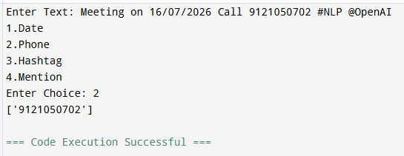

COMPETITIVE PERFORMANCE:
The program efficiently searches text using Python Regular Expressions and produces results with minimal execution time.

TEST CASE HANDLING:
Choice | Input Available | Output
1 | 12/09/2026 | Date Found
2 | 9876543210 | Phone Found
3 | #NLP | Hashtag Found
4 | @OpenAI | Mention Found

RESULT:
The program successfully searches and displays matching patterns using Regular Expressions.

Rubrics for Calculation
Criteria | Weightage | Level 4 – Exemplary | Level 3 – Proficient | Level 2 – Developing | Level 1 – Beginning
Problem Understanding | 20% | Clearly understands problem constraints, edge cases, and competitive requirements | Understands problem with minor gaps in constraints | Partial understanding; misses key constraints | Misinterprets problem or constraints
Algorithm | 25% | Selects optimal algorithm with best time and space complexity for competitive constraints | Uses efficient algorithm with minor scope for improvement | Uses basic/inefficient approach | No clear algorithmic approach
Code Implementation | 20% | Writes correct, efficient, and clean code that passes all constraints | Code works with minor errors or inefficiencies | Partially correct code; fails for some cases | Code does not execute or gives incorrect results
Competitive Performance | 20% | Solves problem within time limits and handles large inputs effectively | Solves within acceptable time with minor delays | Struggles with time limits or larger inputs | Unable to solve within time constraints
Test Case Handling | 15% | Handles all test cases including edge and hidden cases | Handles most test cases | Misses important edge cases | Fails on multiple test cases

Q. No. / Criteria | Problem Understanding | Algorithm | Code Implementation | Competitive Performance | Test Case Handling | Sub. Total | Total %
1
2
3

Faculty In-charge | Course Coordinator | Program Director
Signature: _______________ | Signature: _______________ | Signature: _______________
Date: ___________________ | Date: ___________________ | Date: ___________________

